Click on the videos below to view our ‘Pippins Experts’ speaking key phrases in Bengali!
numbers

Our Bengali Expert!

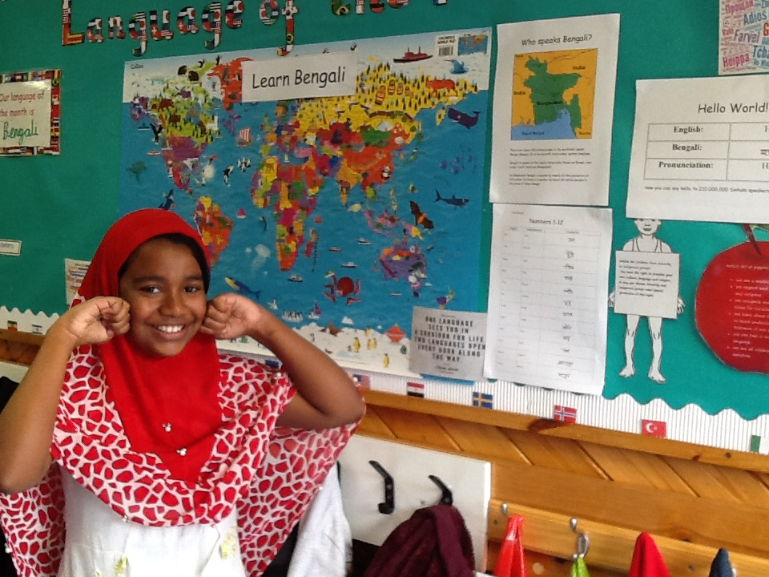

Who speaks Bengali?

There are about 210 million people in the world who speak Bengal (Bangla). It is the seventh most widely spoken language.

Bengali is spoken in the region historically known as Bengal, now lying in both India and Bangladesh.

In Bangladesh Bengali is spoken by nearly all the population of 125 million. In India it is spoken by about 80 million people in the state of West Bengal.
English | Transliteration | Translation
Welcome | Swa-ga-tam
Hello | Hello | 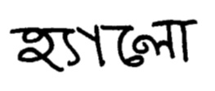
Goodbye | Bee-dai | 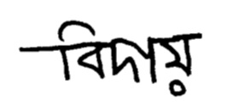
Good morning | Shu-pro-bhat
Good afternoon | Shu-baw-dhupur
Thank you | Dhanya-bad
Sorry | Doo-kee-tow
Please | Do-ya ko-ray
Yes | Ha
No | Naa
Come here | Akane-asho
Well done | Khub-bhaa-lo

