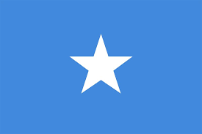
Language of the Term - Somali

This term our focus language has been Somali, which has tied in with Black History Month. We have had a lot of fun learning key phrases in Somali and creating fact files all about the culture and language of Somalia. It has been wonderful to see the children engaging in role play and practicing key phrases with their friends! We held an assembly to give our Somali speaking children at Pippins a chance to teach us all key phrases and the numbers 1-10! Year 2 children created some fantastic posters and fact files of Somalia, through their own research at home. The children enjoyed presenting their posters in our whole school assembly. We are so proud of the children, who have really embraced learning a new language.
Next term our language focus will be Hindi. To all our Hindi speaking parents, please come forward and let us know if you would like to be part of the end of the next assembly. Maybe you could read a traditional story in Hindi, bring in cultural artefacts, talk about your cultural heritage or something else you would like to share with us. Thank you for your support.
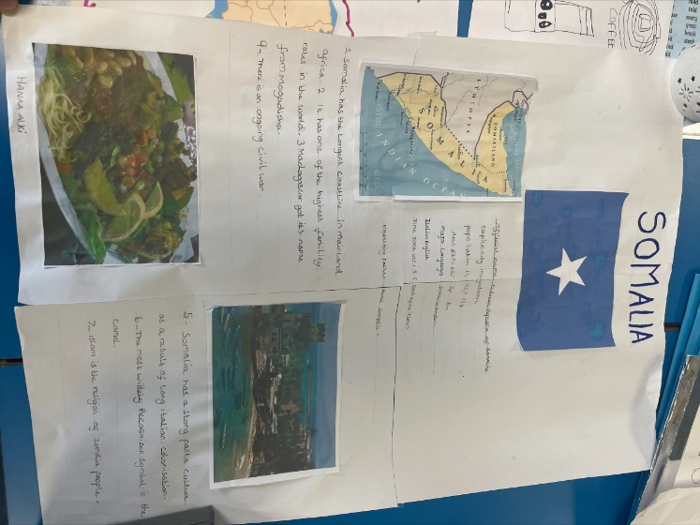
Mrs Rehinsi
Our Somalian language experts teaching us all some key phrases!
